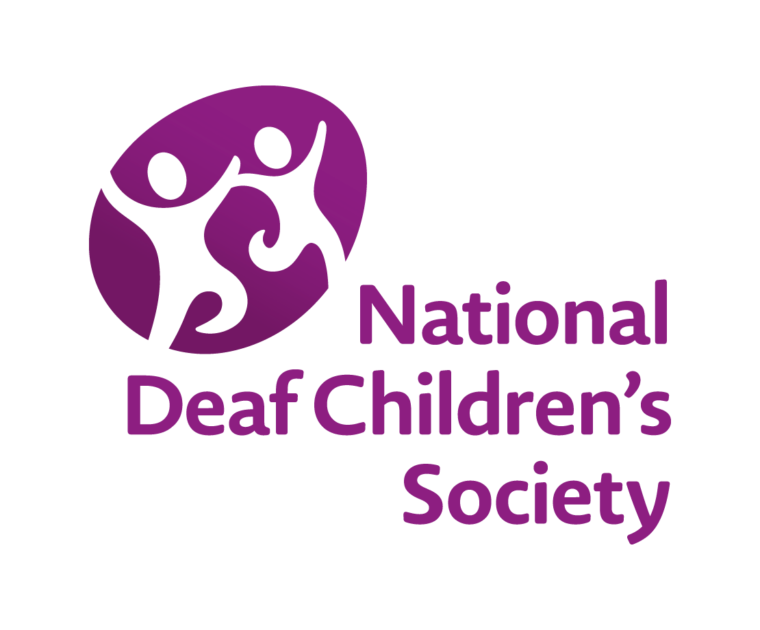

Quality standards: Early years support for children with a hearing loss, aged 0 to 5 (England) self-audit tool

This audit tool has been produced for commissioners and service providers to enable them to review and monitor the extent to which they meet the National Deaf Children’s Society quality standards for early years support for children with a hearing loss, aged 0 to 5.
Background information on the quality standards and all references can be found in the resource setting out the quality standards, available at www.ndcs.org.uk/QSEY.
These standards apply to children who are identified with permanent deafness in one or both ears.

The National Deaf Children’s Society is the leading charity dedicated to creating a world without barriers for deaf children and young people across the UK.
We use the term ‘deaf’ to refer to all types of hearing loss from mild to profound. This includes deafness in one ear or temporary hearing loss such as glue ear.
We use the word ‘parent’ to refer to all parents and carers of children.
© The National Deaf Children’s Society Last reviewed: November 2016
Give us your feedback by emailing your comments to informationteam@ndcs.org.uk

Domain A: The timely and effective identification of a deafness and the child’s needs

Standards | Stage of development | Evidence | Action points
A1 Screening and early identification of newborn babies is carried out in accordance with:  a) the NHS Newborn Hearing Screening Programme Standards 2016  b) the Newborn Hearing Screening programme specification, which includes requirements for:  - making sure parents are given information about the screening and given opportunities to ask questions and seek clarification  - the maintenance of screening equipment and training of staff. | Well developed ☐  Partially developed ☐  Not developed ☐
A2 There is an agreed policy, and protocols, for the surveillance of progressive and late onset deafness in babies and young children. | Well developed ☐  Partially developed ☐  Not developed ☐
A3 Audiology providers work to nationally agreed paediatric assessment guidance. They should tell education and health services within two working days of a hearing loss being identified. | Well developed ☐  Partially developed ☐  Not developed ☐
A4 Education, health and social care professionals work as a multidisciplinary team for the child and family, making sure the child’s needs are assessed, the parents and the child (as they get older) are fully involved, and using all information given by the family. | Well developed ☐  Partially developed ☐  Not developed ☐
A5 Deaf babies and children who meet the criteria to be candidates to receive a cochlear implant or other implant are referred to an auditory implant service at an early stage for assessment, following discussion with the family. During the assessment period, local services liaise with the auditory implant service to ensure the family receive multidisciplinary support and care, and a consistent trial and functional assessment of hearing aids is undertaken in the child’s usual environments. | Well developed ☐  Partially developed ☐  Not developed ☐
A6 A range of developmental assessments is undertaken by appropriately qualified staff in full partnership with the family that:
a) use early developmental measures drawing from resources such as the Early Support Monitoring Protocol | Well developed ☐  Partially developed ☐  Not developed ☐
b) include relevant specialist assessments, particularly in areas where the child is experiencing, or likely to experience, difficulties in making progress in an area of development. In particular, qualified specialists such as speech and language therapists and Teachers of the Deaf, should carry out specialist assessments in speech, language and communication according to local protocols | Well developed ☐  Partially developed ☐  Not developed ☐
c) be followed up with a written report, normally provided within 10 working days of the assessment, which describes the assessment results in a way that parents can clearly understand, and suggests strategies and support for addressing any difficulties the child is experiencing | Well developed ☐  Partially developed ☐  Not developed ☐
d) include regular vision and balance checks given the high prevalence of visual impairment and balance (vestibular) disorders in children with a hearing loss. | Well developed ☐  Partially developed ☐  Not developed ☐
A7 Assessments include the child’s language and communication needs and the capacity of the parents to meet their child’s hearing needs (e.g. by attending audiology clinics, making sure the child is regularly wearing working hearing aids). The assessments also include recommendations for support. | Well developed ☐  Partially developed ☐  Not developed ☐
A8 All information from assessments is fed back to parents with a clear explanation of what the results mean and the implications for the child. | Well developed ☐  Partially developed ☐  Not developed ☐

Domain B: Effectiveness in assessing and meeting the needs of deaf children

Standards | Stage of development | Evidence | Action points
B1 Following diagnosis, the Teacher of the Deaf contacts the child’s parents within:  a) two working days if diagnosed following newborn hearing screening or  b) five working days if diagnosed with a hearing loss at a later age, outside the screening programme.  At this initial contact parents should be told about the support offered by the service and how they can help their child, as well as having any of their questions answered. | Well developed ☐  Partially developed ☐  Not developed ☐
B2 The contact is followed by a visit, the timing of which is agreed with the parent (and early years setting for older children). This should take place as soon as possible, and no later than 10 working days of the notification. The visit will:  - explain what support is available  - explain the hearing loss and its implications  - (where relevant) explain to the education setting what it can do to ensure the child is included and makes progress  - answer any questions parents and education professionals have. | Well developed ☐  Partially developed ☐  Not developed ☐
B3 Information for parents is clear, balanced and accessible, and provided in a way that meets their language needs and preferences, including in British Sign Language (BSL) where applicable. It includes information on:  - the implications of a hearing loss on the child’s development  - language and communication  - sources of help from statutory services, voluntary organisations, parent support groups, and other sources of support  - the Local Offer. | Well developed ☐  Partially developed ☐  Not developed ☐
B4 Parents are offered the opportunity for their deaf child to have aetiological, (including genetic), investigations. These are carried out by health professionals in accordance with local protocols based on nationally agreed standards. Parents are offered specialist counselling to understand these investigations and the implications. | Well developed ☐  Partially developed ☐  Not developed ☐
B5 Services work within a multidisciplinary pathway covering referrals, assessment, planning and delivering support. | Well developed ☐  Partially developed ☐  Not developed ☐
B6 Early years support teams identify a lead professional responsible for coordinating an individual care package for each deaf child, ensuring parents are fully involved and, as far as possible, the child’s views are taken into account. Each care package is based on the assessment of the child’s needs and focuses on achieving agreed outcomes in key areas of development. It sets out:  - the outcomes and targets with a particular focus on the child’s development in language and communication  - the type and level of support and strategies required to achieve these outcomes, setting out when and how the support will be delivered and who by (e.g. Teacher of the Deaf, speech and language therapist, social care, audiology services, etc.)  - support for parents, paying particular attention to families’ individual cultural, communication and language needs, and the capacity of parents to meet their child’s language, communication and hearing needs (e.g. by attending audiology appointments, making sure their child is regularly wearing working hearing aids)  - support for the child’s early years setting/childminder  - provision of appropriate hearing technology  - arrangements for monitoring and review of the child’s progress and undertaking specialist assessments to inform the way the child and family are supported  - transition plans for nursery and school entry. | Well developed ☐  Partially developed ☐  Not developed ☐
B7 The education service provides information on a child’s assessed needs within four working weeks of the child being allocated a new education setting. | Well developed ☐  Partially developed ☐  Not developed ☐
B8 Audiology services work to nationally agreed paediatric assessment, earmould and hearing aid fitting, verification, and evaluation protocols and good practice guidance. | Well developed ☐  Partially developed ☐  Not developed ☐
B9 Audiology services demonstrate how they meet the post-screening standards in NHS Newborn Hearing Screening Quality Standards produced in 2010. They take part in and maintain accreditation to defined quality standards operating under the umbrella of the United Kingdom Accreditation Schemes (UKAS)/Improving Quality in Physiological Services (IQIPS). | Well developed ☐  Partially developed ☐  Not developed ☐
B10 There is a written policy on candidacy for radio aids. The policy ensures that every child with a hearing loss who would benefit from a radio aid has access to one, in line with National Deaf Children’s Society’s Quality Standards for the Use of Personal FM systems. Families also have the opportunity to trial equipment, with a documented assessment of any functional benefits. | Well developed ☐  Partially developed ☐  Not developed ☐

Domain C: The effectiveness of services in improving outcomes for deaf children

Standards | Stage of development | Evidence | Action points
C1 Children’s progress is measured against the national standards for early years outcomes, in particular, around language and communication, with the aim of maximising the number of children who start school with age- or near age-appropriate language, communication and social skills. | Well developed ☐  Partially developed ☐  Not developed ☐
C2 Developmental assessments are undertaken regularly, as well as at nationally prescribed points, including the Integrated Health and Early Years Review at two years (previously covered by the Healthy Child Programme Review and the Early Years Foundation Stage progress check). During this, professionals are alert to the specific areas of communication, language and personal, social and emotional development in relation to the child’s hearing loss. Use of the Ages & Stages Questionnaire (ASQ-3) is suggested in the review. | Well developed ☐  Partially developed ☐  Not developed ☐
C3 The data relating to progress is used in national benchmarking exercises, such as the National Sensory Impairment Partnership (NatSIP) outcomes benchmarking exercise. | Well developed ☐  Partially developed ☐  Not developed ☐

Domain D: Leadership and management

Standards | Stage of development | Evidence | Action points
D1 Staff working in early year services for deaf children have appropriate professional qualifications and take part in continuing professional development in accordance with the standards and requirements of their particular profession. | Well developed ☐  Partially developed ☐  Not developed ☐
D2 Early years specialists going into the home and into mainstream early years settings are trained in:  - hearing loss and its potential impact on a child’s development  - assessment of need  - working in partnership with other professionals  - early child development  - the development of language and communication  - audiological support  - emotional support and counselling skills  - providing accurate and unbiased information  - monitoring progress. | Well developed ☐  Partially developed ☐  Not developed ☐
D3 There are effective multi-agency and multidisciplinary arrangements for providing leadership and coordinating support for deaf children and their families from different organisations and professionals. These arrangements are carried out by the Children’s Hearing Services Working Group (CHSWG) which:  - is supported by all relevant services, including specialist education, audiology and social care services for deaf children, which contribute towards its effectiveness  - ensures parental involvement  - oversees the implementation and monitoring of quality standards  - carries out an annual survey of service user satisfaction  - annually reviews the outcomes achieved by deaf children  - publishes an annual report  - meets at least twice a year  - keeps records of CHSWG meetings and attendance, ensuring these are publicly available. | Well developed ☐  Partially developed ☐  Not developed ☐
D4 Commissioners work with service providers to keep provision under review and improve the quality of service by:  - reviewing the outcomes achieved by deaf children  - surveying families and early years settings about their experiences and/or making use of any existing surveys carried out by service providers  - considering trends in key performance indicators relating to service quality  - comparing service delivery against national standards and responding to audits or inspections by independent bodies (e.g. Ofsted, Care Quality Commission, accreditation agencies). | Well developed ☐  Partially developed ☐  Not developed ☐

Permanent deafness includes children with long-standing middle ear effusion which would not be expected to resolve naturally before the age of 10, such as children with Down’s syndrome, cleft palate, cystic fibrosis, or primary ciliary dyskinesia.
www.gov.uk/government/publications/newborn-hearing-screening-programme-quality-standards

