

**Creating good listening conditions for learning in education: Preliminary noise survey**

**What is the survey for?**

The survey will help you to assess a nursery or school’s listening environment.

**Who can conduct the survey?**

Parents, teachers, school leaders or a Teacher of the Deaf with permission from senior management.

**How does it work?**

You will need to move around the school, inside and outside, and listen for noises which you think might cause problems for deaf children – examples can be found at [www.ndcs.org.uk/acoustics](http://www.ndcs.org.uk/acoustics). You may already have feedback from the child which will have given you some idea of the types of noises that cause issues, however it’s important that you look for other sources of noise which the child may not have noticed. The picture below shows sounds which can affect noise levels inside a school.

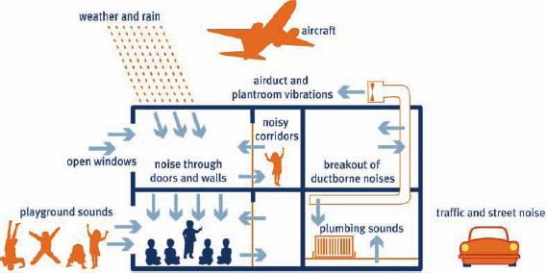

The survey covers:

* noises outside the building
* noises in the classroom when the nursery or school is empty
* noises in the classroom under normal working conditions, with no children in the classroom
* noises in the classroom under normal working conditions with children in the classroom.

**When should I do the survey?**

Try to complete the survey at the time of day when the child said they had most problems with noise. Some noises will be intermittent and may only last a matter of seconds but others will be constant.

**Survey**

Name of person/s undertaking survey…………………………………………………………………………….

Role of person/s undertaking survey……………………………………………………………………………….

**1. Outside the school**

Date ……………………

Time of day ………………………………………..

Weather conditions (it’s important to note the wind direction)…………………..

Stand outside the child’s classroom and list the most obvious noises you hear and roughly how long they last. Then rank them in order of loudness (with 1 being the loudest).



**2. Noise in the classroom when the school is empty**

Date ……………………

Time of day ………………………………………..

Stand in the child’s classroom and list the most obvious noises you hear and roughly how long they last. Then rank them in order of loudness (with 1 being the loudest). This time you need to have the windows open, and heating, ventilation systems and lights on.



**3. Noise in the classroom (normal working conditions, with no children)**

Date ……………………….

Time of day…………………………………..

You should do this when there are no children in the classroom, for example, during playtime or PE. You need to be inside the child’s classroom and listen to the noises coming from around the classroom. List the most obvious noises you hear and roughly how long they last. Then rank them in order of loudness (with 1 being the loudest).



**4. Noise in the classroom (normal working conditions, children in the classroom)**

Date…………………………….

Time of day……………………………………….

Type of lesson……………………………..

You need to be inside the child’s classroom and listen to the noises coming from inside the classroom. List the most obvious noises you hear (including the teacher’s voice) and roughly how long they last. Then rank them in order of loudness (with 1 being the loudest).

This should be the time of the lesson or time of day the child said was most problematic.



After taking this survey you should discuss the results with the child’s parents, teacher, the special educational needs coordinator[1] and other professionals such as the Teacher of the Deaf, local authority officials or an acoustician. The following chart may be useful to help summarise your results and recommended actions.

|  |
| --- |
| **Results and analysis of the preliminary survey** |
| The survey has identified the following issues: |
| After discussions the recommended actions are:   1. …………………………………………………………………………………………………...   Lead person………………………………….Date for completion……………………   1. …………………………………………………………………………………………………...   Lead person………………………………….Date for completion……………………   1. ……………………………………………………………………………………………………   Lead person………………………………….Date for completion……………………  These actions should be SMART (**S**pecific, **M**easurable, **A**ttainable, **R**elevant and **T**ime bound) and achievable rather than aspirational. They could include actions for the school, the teacher or the local authority. |

Last reviewed: December 2019

1. Known in Scotland as an additional learning needs coordinator.